1- Look at the HTTP part of the HTTP GET packet. What HTTP version is used?

1.1

2 -Look at an HTTP response from this server. What Web Server software is www.nethereal.com running?

Apache

3- What are the IP Addresses of Client (Source) and Web Server (Destination)?

* Source: 145.254.160.237
* Destination: 65.208.228.223

4- What port number is being used by Client for this connection?

🡪 3372

5- What port number is being used by the Web Server for this connection?

🡪 80

6 - What is the sequence number of the TCP SYN segment that is used to initiate the TCP connection between the client computer and [www.ethereal.com?](http://www.ethereal.com?)

* 0

7- What is the length of the first TCP segment containing data?

* 1380

**Note: Read this article "*Understanding TCP Sequence and Acknowledgment Numbers"***[**here (Links to an external site.)**](https://packetlife.net/blog/2010/jun/7/understanding-tcp-sequence-acknowledgment-numbers/)**to answer question 8**

8- Analyze how Client and Server are advancing Seq and Ack in both directions?  Note how Seq and Ack are advancing in for the initial four (4) segments with length 1434.

 8- Find the TCP SYN packet in the trace. Note the timestamp of the segment.

* 0.000000000s

9- Can you identify the packets for TCP's connection opening sequence [SYN, SYN+ACK, ACK]? What are the timestamps? Take a snapshot. Highlight the protocol handshake.

* SYN: 0.000000s
* SYN+ACK:0.911310s
* 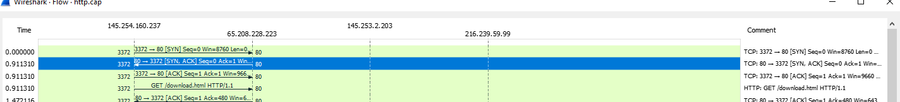ACK: 0.911310s

10- Using Statistics -> TCP Stream Graph [Throughput] what is the maximum Throughput the connection achieved (bits per second)? Note the Throughput in both direction. [Hint: Throughput is given on the right side of the graph]

* 3832 Bps

11- For Window Size, what are the maximum Window Sizes in both directions, for the entirety of the connection?

* 6432